**Data Analytics Project #3 Proposal:**

* Carolyn West
* Chelsea Scheetz
* Devin Wilson
* Lynn Eitelman

**Topic and Rationale:** Our topic is Maternal Mortality. We will be looking at the history of maternal deaths from 1990 to 2015.

The healthcare industry has improved thanks to machine learning but only in most countries. We will analyze the existing data by Region and make a prediction.

Technologies used will be Tableau, HTML/CSS

**Link to primary GitHub repo:** <https://github.com/devinj0325/maternal-mortality>

**Link to data set(s):** <https://ourworldindata.org/maternal-mortality>

<https://www.cdc.gov/mmwr/volumes/68/wr/mm6835a3.htm?s_cid=mm6835a3_w>

**Screenshot of the metadata:**

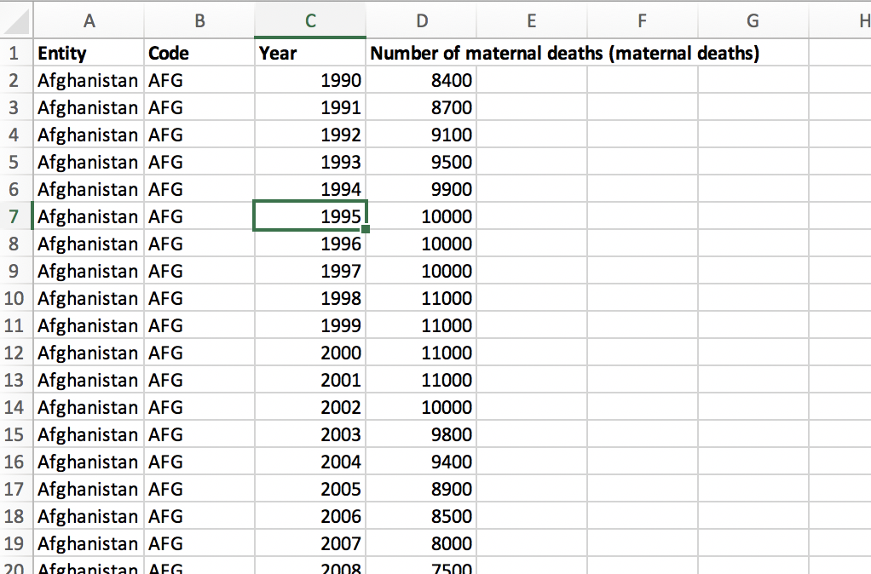

**Screenshots of relevant visualizations:**

